**FLOOD MONITORNING AND EARLY WARNING**

**BATCH MEMBER**

**911721104072: PRAMITHA.G**

**Phase 3 submission document**

**Project Title :** Flood Monitorning System

**Phase3 :** Development Part-1

**Topic :** Start building the flood monitorning model by loading and pre-processing the dataset.



**Flood Monitorning System**

**Introduction:**

* Recent catastrophic floods around the world have spawn a large number of projects aimed at the development of stronger and "smarter" flood protection systems. Many projects, among which are FLOODsite, FloodControl 2015, International Levee Handbook [1], attempt to solve some of the flood control problems. One of the most challenging problems is the design of Early Warning Systems (EWS) for flood prevention and disaster management.
* Floods are amongst the most common and devastating of all natural hazards. The alarming number of flood-related deaths and financial losses suffered annually across the world call for improved response to flood risks. Interestingly, the last decade has presented great opportunities with a series of scholarly activities exploring how camera images and wireless sensor data from Internet-of-Things (IoT) networks can improve flood management.
* Natural hazards such as floods, storms, tsunamis and others pose a significant threat to lives and property around the world.Without proper monitoring and effective mitigation measures, these natural perils often culminate in disasters that have severe implications in terms of economic loss, social disruptions, and damage to the urban environment.
* The global impact of a flood would be more alarming if these statistics incorporated other numerous small-scale floods where less than 10 people may have died, 100 or more people may have been affected or where there is no declaration of a state of emergency or a call for international assistance. Nevertheless, the current situation calls for improved ways of monitoring and responding to floods. The importance of improved flood monitoring cannot be overemphasized given the growing uncertainty associated with climate change and the increasing numbers of people living in flood-prone areas.
* Significant efforts have been made globally to develop cost-effective and robust flood monitoring solutions. A common approach is based on computer vision, wherein relevant images from existing urban surveillance cameras are captured and processed to improve decision making about floods.These types of camera-based applications involve low equipment cost and wide aerial coverage thereby enabling the detection of flood levels at multiple points. The wider coverage gives the computer vision approach an advantage over the traditional flood monitoring method that relies on fixed-point sensors.

**Early Flood Warning Flood Detection using WSN:**

An early detection of flood system was implemented by Basha et al. [12] by means of a short description of sensor networks in Hondurasi meant for the people who are at risk of getting affected by the flood [12]. It included the analysis detailing the significance of sensor networks, available operational applications, and their lower cost in developing countries. The issues pertaining to the detection of floods and cautioning people in the events of disasters were discussed since it can turn into a complex situation. After in-depth analysis, a solution was proposed that uses WSNs. This solution contains four different categories such as flood prediction, notification to the authorities, alerting the community, and evacuation of people. The proposed solution was validated by conducting various experiments. The tests were carried out for different communication ranges such as 144 MHz radio usability. The testing activity requires US antenna towers with line-of-sight for reliable communication in the air available between sensors at those ranges. According to them, sensor network technology could be the best way to prevent damage by detecting floods in developing countries. An early flood warning system described the architecture and deployment strategy to meet the requirements. It permits enhancing the forecasting capability of the system using model-driven control. The design was created in Honduras with its utilization to detect and analyze the flood forecast. An integrated form of the forecasting technique that includes network design and testing of the attached components was utilized by the developer of this system. By deploying the system on the banks of the river in Massachusetts, they achieved a successful outcome in the field examinations. According to the framework, a very unique heterogeneous communication system was utilized by setting sensors over the river basin. These sensors could read real-time data and auto-monitor to adjust their readings if required. These readings help in estimation techniques to address disasters such as floods. The proposed model as shown in Fig. 1 has an innovative procedure to forecast floods and which utilizes information received from installed sensors that are spatially distributed in nature. A productive Sacramento Soil Moisture Accounting (SACSMA) model has been utilized for detecting floods effectively. Nonetheless, in the case of flood detections in developing countries, SACSMA is an expensive strategy for deployment. Their methodology has easier calculations in comparison to the traditional method to handle floods, using continuous data from sensor hubs. It has an advantage over the SACSMA model. An early warning system is shown in Figure 1. Figure 1. Early Flood Warning Model [12] By alluding to the model executed as a reference, certainly, developing and underdeveloped nations are greatly influenced by floods on an annual basis. A low-cost and efficient flood detection mechanism can be created and effectively deployed using currently accessible technologies such as WiFi and ZigBee. Additionally, planning and securely documenting the identified information for further flood prediction. The IoT and cloud computing efficiently store and helps in analyzing the sensor data.

## Background of Study

Flood is one of the major disasters which effects many people in many countries around the world each year. It damages lives, natural source and environment as well as causing the loss of economic. Figure 1 shows the statistic of the disasters that occurred in Malaysia from 1980 to 2010 [1] including earthquakes, tsunamis, flood and epidemics. Among these disasters, flood records the highest occurrence. The impact of floods has been increased due to a number of factors such as rising sea levels and relentless rain.

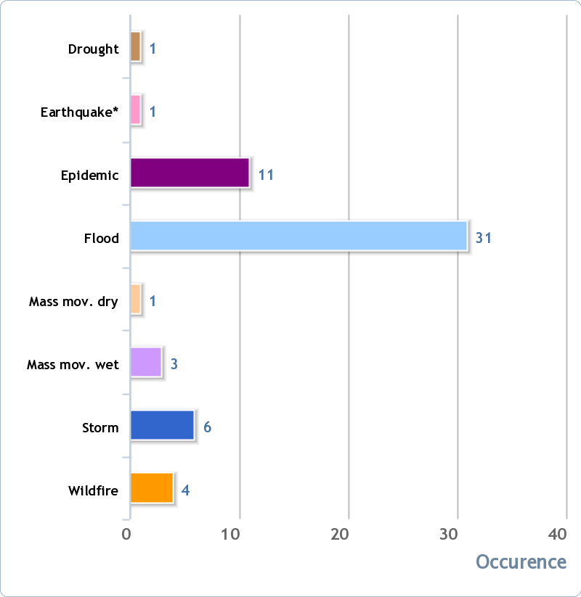

In Malaysia, river flood and flash flood are two common floods that usually occur every year. Flash flood occurs due to slow-moving thunderstorm that repeatedly moving over the same area or heavy rain from hurricane and tropical storms. It takes about several minutes to hours to develop. It can also occurs due to man-made dam collapse as an example. Normally, flash flood occurs 6 to 7 hours after heavy rainfall, meanwhile river flood occurs longer and lasted a week or more. Flash flood is not seasonal but it can happen anytime and it has certain limitations compared to the river flooding. Normally floodwater moves with fast speed and flash flooding occurs when a barrier holding back water fails or when water falls too quickly on saturated soil or dry soil that has poor absorption ability. Flash floods often occur in a dry place and do not have a good drainage system.

However, river flood (monsoon flooding) happens during local tropical wet season generally around the month of October to March. Flooding occurs when heavy rain lasting for several days or when heavy rain in a short period causes a river or stream water levels submerge to land. Normally, this flood occurs at east coast countries such as Kelantan, Pahang and Terengganu. A river flood is common natural disaster. River flooding causes loss of human life and damages property. Every year, the amount of deaths from river flooding is more than any other natural disaster in Malaysia.

Flood Monitoring system is one of the technologies that can be used to prevent loss of life in floods mainly in the east coast states like Kelantan , Terengganu and Pahang. The alarm system can be integrated into the system to alert public and authorities on flood to avoid loss of life. Such system is called a flood monitoring system with GSM. The system requires the need of telecomunication services from companies like Maxis, Celcom and Telekom Malaysia. The function of this system is to measure the water level of river and when the water level is beyond the threshold level, it will send a notification to the user. This system is specially designed for rescue team such as PDRM, BOMBA and JPAM. With this system, the rescue team will get the water level information and alert the information to the public especially flood victims for evacuation purposes.

## Problem Statement

Most of the flood monitoring techniques are based on telemetry systems which require transmitters and repeaters to relay the information to a central terminal. This approach is expensive and is not reliable when there is malfunction of equipment in some section of the sensed area. Some other techniques are dependent on the communication infrastructure of some third-party providers making them unreliable. Therefore, there is a need to build a low cost and reliable system using a wireless sensor network.

## Objectives

The objectives of the project are:

* + - To develop a sensor network device for sensing water level
    - To develop processing and transmission units using GSM

## Scope of Study

This project focuses on the nearby area that is affected by recent flood at Sungai Perak. The proposed system was installed and tested at Rumah Pam Sungai Perak with the permission and consultation from Department of Irrigation and Drainage (JPS) Perak Tengah. Water level data was collected and updated from time to time to monitor the changes in the water level.

## What is Flooding?

Flooding is a situation in which water from a river or from rain covers large areas of land. It is also defined as a temporary rise of the water level, as in a river or lake or along a seacoast, resulting in its spilling over and out of its natural or artificial confines onto land that is normally dry. Flooding in Malaysia is a normal phenomenon occuring every year. It usually occurs in low surface area and exposed to the river. It can occur at the city or metropolitan area like Kuala Lumpur, Johor Bharu and Pulau Pinang due to the limited drainage systems which fail to bear the excessive rain water.

According to [2], flooding commonly happens at the dry area, but suddenly gets submerged under water. Flooding can happen all of a sudden and retreated rapidly. It also takes a long time for the water to recede. Flood can also occur at irregular intervals and vary in size, duration and area affected. During flood, water flows from high area to low lying area. This means low-laying areas might be flooded quickly before it starts to get to higher ground. This can be illustrated by Figure 2.

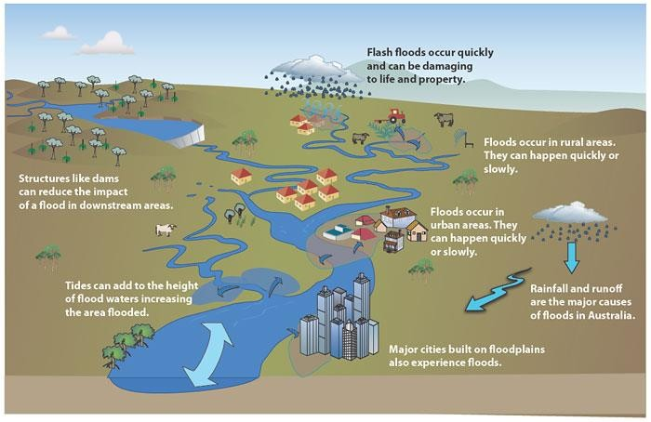

## Types of flooding within Malaysia

## Flash Flooding

Flash Flood is a short-term flood, normally occurs within 6-7 hours of the heavy rain and often within 2 hours of the start of high intensity rainfall. Figure 3 shows the flash floods. It can be described as a rapid river rise with depth of water that can reach beyond the river. It most likely to occur in areas adjacent to the river. Flash flood can also happen when there are thunderstorms that occur in the same areas. At the same time, when storms move faster, flash flooding is less likely to happen because the rain is moving into a wide area. It can also occur even if no rain has fallen like operations such as after levees or dams have failed, or after the release of a sudden the water by debris [3].

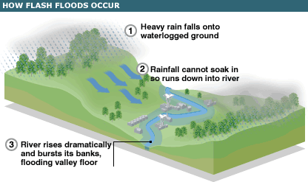

## River Flooding

Floods are natural events every year. Usually, that occurs at east coast state such as Kelantan, Pahang and Terengganu. It depends to movement of the monsoon and occurs on October to March every year within Peninsular Malaysia. It can occur at Sabah and Sarawak state. River flood is almost similar to monsoon flooding because river flooding depend on the heavy rainfall. River floods happen when the river catchment that is the zone of area that supports water into the river and the streams contains excess water level, for example, through precipitation. The river can’t adjust the precipitation during heavy rain and this additional water causes the water level in the river to increase and floods to happen. The river floods may take place at any areas along the river course.

River flooding can also occur when a river or stream to flood stage, and the water will rise and spill over the banks of the river. Number of river flooding from rainfall usually depends on an area, the amount of time required for the rain to gather, before saturation local land and the land around the river system. For example, a river or stream that is in the board, flat floodplain will often produce a continuous flood and flood waters in an area that does not subside for long periods. The most river flooding occurs at the low-lying place and adjacent to the river [5]. Figure 4 shows river flood occur. The impact of river flooding can be fatal if a flooding river overflowing quickly. It causes loss of life due to drowning, loss of property and causes disruption of living [4].

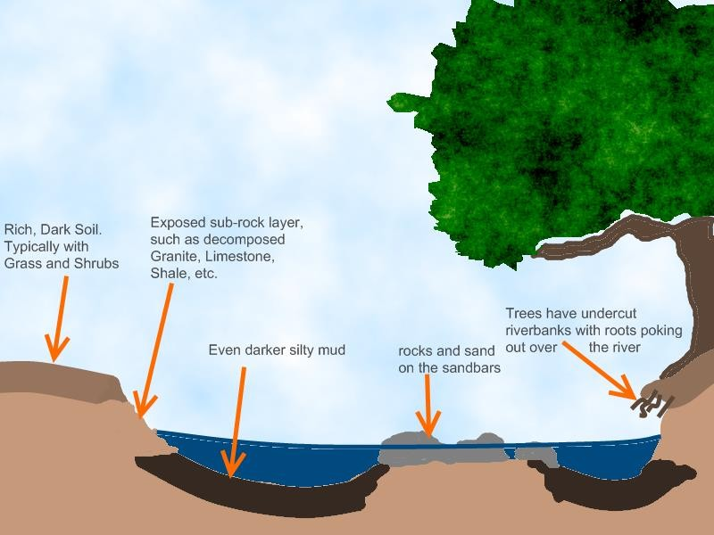

## Floor Monitoring and Warning Technologies

There are two common flood systems implemented namely flood monitoring and warning system and flood monitoring alone. Section will describe the flood monitoring and warning system while Section will describe the flood monitoring system without the warning system. This project falls under the category described in Section with different approach in alerting using the SMS system.

The following sections provide an overview of existing technologies used for flood monitoring and warning system and flood monitoring system.

## Flood Monitoring and Warning System

Flood monitoring and warning system using real-time sensor is one of the flood controls measures. This system not only monitors the flood but also has some warning or alert mechanism to notify people. Losses due to flooding can be reduced by measures such as monitoring, forecasting, simulation and evaluation of water level [6]. According to [7-8], one of the measuring flood systems is using a wireless sensor and web – based decision support system in monitoring, controlling, relieving, and assessing natural disasters, particularly flood disaster. Implementation of the monitoring and flood warning system is not unimportant, if not it requires reliability coupled with the correct information. The sensor network is one of the sensor technologies used to detect the level of increase in the water level and air temperature. The sensor network in this case is a pressure sensor, temperature sensor and rain sensor. In the work , sensor nodes are placed on the tree by the river to measure the water level and air temperature in the river and the data is recorded every 5 minutes and transmitted to base station via GPRS systems.

One limited factor in the system is the factor of distance in which each sensor node has restricted distance and having the frequency which is fixed. In project, each sensor node used 144MHz as a frequency and in communication range is 25km. For example, field testing will has a lot of sensor nodes in order to communicate smoothly and less signal losses. Each sensor node needs to update the state of the river water to the base station. Figure 5 shows the architecture of the system in and explains how the nodes communicate.

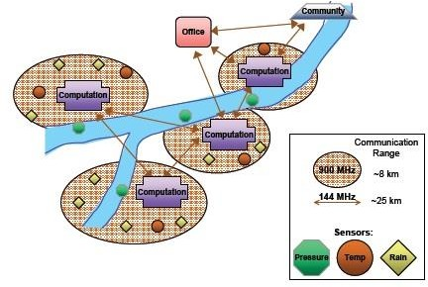

In the wireless sensor network there are many types of sensor used such as Honeywell pressure sensor, instrumentation amplifier and computation electronic. In project [10], three types of sensor nodes are used. The first sensor is a hydrological sensor, where this sensor serves to monitor the water level and water flow. The second sensor is a meteorological sensor nodes used to monitor light, temperature, humidity, barometric pressure, wind pressure and wind speed. The third sensor node [10] is landslide, used as a detection area exposed to the hazard.

## Flood Monitoring System

Flood monitoring system is different from flood monitoring and warning system as it does not have an alerting mechanism. According to [15], almost flood monitoring system is associated with flood forecasting to make decisions about whether flood warning shall be issued to the public or whether previous warnings should be canceled or withdrawn. Figure 6 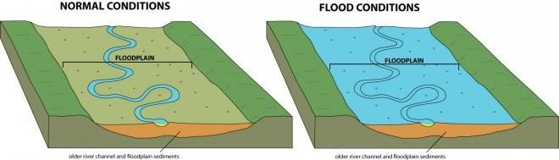shows different conditions between normal and flood.

Pakistan, Thailand, Hong Kong and many others have flood monitoring systems. In Malaysia, the government has set up a team or department to control and give warning to the state’s major rivers which are prone to flooding. Authorities also play an important role to ensure that survivors of the flood affected population. Authorities also need to help the residents to evacuate. In the flood situation, many parties need help to alleviate the burden of population vulnerable to flooding. This system is designed to warn about the state of the adjacent river water.

## Calculation System

This system uses an ultrasonic sensor to measure the distance of water level at the river. The microcontrollers do the processing using the measurement data from ultrasonic sensor. In this case, this system used the Arduino ATMega328 as a microcontroller. Ultrasonic (PING) has two transducers. Each transducer has a role. The transducer knows as emits a pulse of high frequency sound sounds waves and detect reflected sound waves that impact a surface such a water level.

Distance of ultrasonic can be determined with the measuring the time interval between sending the pulse and receiving the reflection or echo and convert the distance based on the speed of sound. This sensor can be used any application and to perform measurement between moving or static object [11]. The signal emitted by the ultrasonic transmitter frequency 40Hz and handled by transmitter circuit. The propagation range of transmitter 340 m/s with sound velocity. For receiver, the signal

will reflected by the ultrasonic receiver, then the receiver signal will be processed to calculate the distance. The distance is calculated by this formula ***S = 340t/2,*** where S is the distance between ultrasonic to the reflected field, and t is difference of timing between transmitter and receiver.

## Jabatan Pengairan Dan Saliran Malaysia System

For Malaysia, Drainage and Irrigation Department is a department that was established to investigate the current state of the water level in the river [13]. Drainage and Irrigation Department (JPS) Malaysia uses several ways to measure the water in the river face, one way is a telemetry where the sensor will be placed under the pump house. The telemetry acts when the water looks up and exposed on the sensor and the sensor deliver the data to the host in the space provided. In that position also provides data water level through the website. The data will updated every 1 hour to the website application, this system shows in Malaysia only have one way to monitor and alert of the flood. In telemetry systems just only detect the water level. Figure 8 shows that the data contained in the water at the Perak State River and figure 7 shows the hydrograph for Sungai Perak at Parit in Perak Tengah.

#include <mega8.h> #include <stdio.h>

void usart_init(void) { UCSRB = (1<<TXEN)|(1<<RXEN); UCSRC = (1<<UCSZ1)|(1<<UCSZ0)|(1<<URSEL); UBRRL = 0X33; }

void usart_sendchar(unsigned char ch)

{ while(!(UCSRA & (1<<UDRE))); UDR = ch;}

void usart_sendstring(unsigned char *str)

{ unsigned char i=0;

while(str[i]!= '\0') { while(!(UCSRA & (1<<UDRE))); UDR = str[i];

i++; }

i=0; }

char usart_readchar() { while(!(UCSRA & (1<<RXC))); return UDR; }

void sendmsg(unsigned char *msg)

{ char cmd[25];

unsigned char num1[] = {"\"9424743297\""}; unsigned char num2[] = {"\"8989828523\""}; unsigned char num3[] = {"\"8400137397\""}; unsigned char num4[] = {"\"9479845436\""}; unsigned char num5[] = {"\"9415557019\""}; usart_init();

sprintf(cmd,"AT+CMGS=%s",num1); usart_sendstring(cmd); usart_sendchar(0x1A); usart_sendstring(msg); usart_sendchar(0x1A); sprintf(cmd,"AT+CMGS=%s",num2); usart_sendstring(cmd); usart_sendchar(0x1A);

usart_sendstring(msg); usart_sendchar(0x1A); sprintf(cmd,"AT+CMGS=%s",num3); usart_sendstring(cmd); usart_sendchar(0x1A); usart_sendstring(msg); usart_sendchar(0x1A); sprintf(cmd,"AT+CMGS=%s",num4); usart_sendstring(cmd); usart_sendchar(0x1A); usart_sendstring(msg); usart_sendchar(0x1A); sprintf(cmd,"AT+CMGS=%s",num5); usart_sendstring(cmd); usart_sendchar(0x1A); usart_sendstring(msg); usart_sendchar(0x1A);

}

void main(void)

{

char cmd[25]; int send = 0;

DDRB=(0<<DDB7) | (0<<DDB6) | (0<<DDB5) | (0<<DDB4) | (0<<DDB3) | (0<<DDB2) | (0<<DDB1) | (0<<DDB0);

PORTB=(0<<PORTB7) | (0<<PORTB6) | (0<<PORTB5) | (0<<PORTB4) | (0<<PORTB3) | (0<<PORTB2) | (0<<PORTB1) | (0<<PORTB0);

DDRC=(0<<DDC6) | (0<<DDC5) | (0<<DDC4) | (0<<DDC3) | (0<<DDC2) | (0<<DDC1) | (0<<DDC0); PORTC=(0<<PORTC6) | (0<<PORTC5) | (0<<PORTC4) | (0<<PORTC3) | (0<<PORTC2) | (0<<PORTC1) | (0<<PORTC0); DDRD=(0<<DDD7) | (0<<DDD6) | (0<<DDD5) | (0<<DDD4) | (0<<DDD3) | (0<<DDD2) | (0<<DDD1) | (0<<DDD0);

PORTD=(0<<PORTD7) | (0<<PORTD6) | (0<<PORTD5) | (0<<PORTD4) | (0<<PORTD3) | (0<<PORTD2) | (0<<PORTD1) | (0<<PORTD0);

TCCR0=(0<<CS02) | (0<<CS01) | (0<<CS00); TCNT0=0x00;

TCCR1A=(0<<COM1A1) | (0<<COM1A0) | (0<<COM1B1) | (0<<COM1B0) | (0<<WGM11) | (0<<WGM10); TCCR1B=(0<<ICNC1) | (0<<ICES1) | (0<<WGM13) | (0<<WGM12) | (0<<CS12) | (0<<CS11) | (0<<CS10); TCNT1H=0x00;

TCNT1L=0x00; ICR1H=0x00; ICR1L=0x00; OCR1AH=0x00; OCR1AL=0x00;

OCR1BH=0x00; OCR1BL=0x00; ASSR=0<<AS2;

TCCR2=(0<<PWM2) | (0<<COM21) | (0<<COM20) | (0<<CTC2) | (0<<CS22) | (0<<CS21) | (0<<CS20); TCNT2=0x00;

OCR2=0x00;

TIMSK=(0<<OCIE2) | (0<<TOIE2) | (0<<TICIE1) | (0<<OCIE1A) | (0<<OCIE1B) | (0<<TOIE1) | (0<<TOIE0); MCUCR=(0<<ISC11) | (0<<ISC10) | (0<<ISC01) | (0<<ISC00);

UCSRA=(0<<RXC) | (0<<TXC) | (0<<UDRE) | (0<<FE) | (0<<DOR) | (0<<UPE) | (0<<U2X) | (0<<MPCM); UCSRB=(0<<RXCIE) | (0<<TXCIE) | (0<<UDRIE) | (1<<RXEN) | (1<<TXEN) | (0<<UCSZ2) | (0<<RXB8) | (0<<TXB8); UCSRC=(1<<URSEL) | (0<<UMSEL) | (0<<UPM1) | (0<<UPM0) | (0<<USBS) | (1<<UCSZ1) | (1<<UCSZ0) | (0<<UCPOL); UBRRH=0x00;

UBRRL=0x33;

ACSR=(1<<ACD) | (0<<ACBG) | (0<<ACO) | (0<<ACI) | (0<<ACIE) | (0<<ACIC) | (0<<ACIS1) | (0<<ACIS0); SFIOR=(0<<ACME);

ADCSRA=(0<<ADEN) | (0<<ADSC) | (0<<ADFR) | (0<<ADIF) | (0<<ADIE) | (0<<ADPS2) | (0<<ADPS1) | (0<<ADPS0); SPCR=(0<<SPIE) | (0<<SPE) | (0<<DORD) | (0<<MSTR) | (0<<CPOL) | (0<<CPHA) | (0<<SPR1) | (0<<SPR0); TWCR=(0<<TWEA) | (0<<TWSTA) | (0<<TWSTO) | (0<<TWEN) | (0<<TWIE);

while(1) {send = PORTC && (0b10111111);

if(send == 0b11111111) { sendmsg("\rFLOOD LEVEL INCREASING.PACK YOUR IMPORTANT ITEMS\r"); send = 0b00000000; }

if(send == 0b11111111) { sendmsg("\rFLOOD LEVEL HIGH\r"); send = 0b00000000; }

if(send == 0b11111111) { sendmsg("\rFLOOD APPROACHING IN THIS AREA DUE TO RISING WATER LEVEL IN THE YAMUNA RIVER\r"); send = 0b00000000; }

if(send == 0b11111111) {sendmsg("\rALARMING FLOOD LEVEL.RUN OUT OF YOUR HOUSE AS SOON AS POSSIBLE\r"); send=0b00000000; } } }

* 1. RF Receiver code:

#include <mega8.h> #include <delay.h> #include <stdio.h>

#define ADC_VREF_TYPE ((0<<REFS1) | (0<<REFS0) | (1<<ADLAR))

#ifndef F_CPU

#define F_CPU 4000000 #endif

#define BAUDRATE 1200

#define UBRRVAL ((F_CPU/(BAUDRATE*16UL))-1)

void inituart(void){ UBRRL = UBRRVAL;

UBRRH = (UBRRVAL>>8); UCSRC|=(1<<URSEL)|(1<<UCSZ1)|(1<<UCSZ0); UCSRB=(1<<RXEN)|(1<<TXEN);}

void writechar(char ch)

{ while(!(UCSRA & (1<<UDRE)));

UDR=ch;}

void writestring(unsigned char *str)

{ unsigned char i=0; while(str[i]!= '\0')

{ while(!(UCSRA & (1<<UDRE)));

UDR = str[i]; i++; }

i=0;}

unsigned char readchar()

{ while(!(UCSRA & (1<<RXC)));

return UDR;}

unsigned char read_adc(unsigned char adc_input)

{ ADMUX=adc_input | ADC_VREF_TYPE; delay_us(10);

ADCSRA|=(1<<ADSC);

while ((ADCSRA & (1<<ADIF))==0); ADCSRA|=(1<<ADIF);

return ADCH;} void main(void)

{ char ch;

DDRB=(0<<DDB7) | (0<<DDB6) | (0<<DDB5) | (0<<DDB4) | (0<<DDB3) | (0<<DDB2) | (0<<DDB1) | (0<<DDB0); PORTB=(0<<PORTB7) | (0<<PORTB6) | (0<<PORTB5) | (0<<PORTB4) | (0<<PORTB3) | (0<<PORTB2) | (0<<PORTB1) | (0<<PORTB0);

DDRC=(0<<DDC6) | (0<<DDC5) | (0<<DDC4) | (0<<DDC3) | (0<<DDC2) | (0<<DDC1) | (0<<DDC0); PORTC=(0<<PORTC6) | (0<<PORTC5) | (0<<PORTC4) | (0<<PORTC3) | (0<<PORTC2) | (0<<PORTC1) | (0<<PORTC0);

DDRD=(0<<DDD7) | (0<<DDD6) | (0<<DDD5) | (0<<DDD4) | (0<<DDD3) | (0<<DDD2) | (0<<DDD1) | (0<<DDD0); PORTD=(0<<PORTD7) | (0<<PORTD6) | (0<<PORTD5) | (0<<PORTD4) | (0<<PORTD3) | (0<<PORTD2) | (0<<PORTD1) | (0<<PORTD0);

TCCR0=(0<<CS02) | (0<<CS01) | (0<<CS00); TCNT0=0x00;

TCCR1A=(0<<COM1A1) | (0<<COM1A0) | (0<<COM1B1) | (0<<COM1B0) | (0<<WGM11) | (0<<WGM10); TCCR1B=(0<<ICNC1) | (0<<ICES1) | (0<<WGM13) | (0<<WGM12) | (0<<CS12) | (0<<CS11) | (0<<CS10); TCNT1H=0x00;

TCNT1L=0x00; ICR1H=0x00; ICR1L=0x00; OCR1AH=0x00; OCR1AL=0x00; OCR1BH=0x00; OCR1BL=0x00; ASSR=0<<AS2;

TCCR2=(0<<PWM2) | (0<<COM21) | (0<<COM20) | (0<<CTC2) | (0<<CS22) | (0<<CS21) | (0<<CS20); TCNT2=0x00;

OCR2=0x00;

TIMSK=(0<<OCIE2) | (0<<TOIE2) | (0<<TICIE1) | (0<<OCIE1A) | (0<<OCIE1B) | (0<<TOIE1) | (0<<TOIE0); MCUCR=(0<<ISC11) | (0<<ISC10) | (0<<ISC01) | (0<<ISC00);

UCSRA=(0<<RXC) | (0<<TXC) | (0<<UDRE) | (0<<FE) | (0<<DOR) | (0<<UPE) | (0<<U2X) | (0<<MPCM); UCSRB=(0<<RXCIE) | (0<<TXCIE) | (0<<UDRIE) | (1<<RXEN) | (1<<TXEN) | (0<<UCSZ2) | (0<<RXB8) | (0<<TXB8); UCSRC=(1<<URSEL) | (0<<UMSEL) | (0<<UPM1) | (0<<UPM0) | (0<<USBS) | (1<<UCSZ1) | (1<<UCSZ0) | (0<<UCPOL);

UBRRH=0x00; UBRRL=0x33;

ACSR=(1<<ACD) | (0<<ACBG) | (0<<ACO) | (0<<ACI) | (0<<ACIE) | (0<<ACIC) | (0<<ACIS1) | (0<<ACIS0); ADMUX=ADC_VREF_TYPE;

ADCSRA=(1<<ADEN) | (0<<ADSC) | (0<<ADFR) | (0<<ADIF) | (0<<ADIE) | (0<<ADPS2) | (1<<ADPS1) | (1<<ADPS0); SFIOR=(0<<ACME);

SPCR=(0<<SPIE) | (0<<SPE) | (0<<DORD) | (0<<MSTR) | (0<<CPOL) | (0<<CPHA) | (0<<SPR1) | (0<<SPR0); TWCR=(0<<TWEA) | (0<<TWSTA) | (0<<TWSTO) | (0<<TWEN) | (0<<TWIE);

while (1) {

inituart();

ch = readchar(); delay_us(100); writechar(ch); delay_us(100);

if(ch =='a'){ writestring("\rThere is an urgent need of rescue team at \"SADAR\"\r"); delay_ms(10);}

if(ch =='b') { writestring("\rThere is an urgent need of rescue team at \"BUS-STAND\"\r"); delay_ms(10); }

if(ch =='c')

{ writestring("\rThere is an urgent need of rescue team at \"SAMDARIYA\"\r"); delay_ms(10); }

if(ch =='d'){ writestring("\rThere is an urgent need of rescue team at \"SOUTH AVENUE MALL\"\r"); delay_ms(10); }

if(ch =='e')

{ writestring("\rThere is an urgent need of rescue team at \"RUSSEL CHOWK\"\r"); delay_ms(10); }

if(ch =='f')

{ writestring("\rThere is an urgent need of rescue team at \"GWARI-GHAT\"\r"); delay_ms(10);}

if(ch =='g') { writestring("\rThere is an urgent need of rescue team at \"BHEDAGHAT\"\r"); delay_ms(10); }

if(ch =='h') { writestring("\rThere is an urgent need of rescue team at \"DUMNA ROAD\"\r"); delay_ms(10); } }}

* 1. **RF transmitter code:**

#include <mega8.h> #include <delay.h> #include <stdio.h> #ifndef F_CPU

#define F_CPU 8000000 #endif

#define BAUDRATE 9600

#define UBRRVAL ((F_CPU/(BAUDRATE*16UL))-1)

#define ADC_VREF_TYPE ((0<<REFS1) | (0<<REFS0) | (1<<ADLAR))

void usart_init(void){ UCSRB = (1<<TXEN)|(1<<RXEN); UCSRC = (1<<UCSZ1)|(1<<UCSZ0)|(1<<URSEL); UBRRL = 0x33;

UBRRH = 0; }

void usart_sendchar(unsigned char ch){while(!(UCSRA & (1<<UDRE))); UDR = ch;}

void usart_sendstring(unsigned char *str){unsigned char i=0; while(str[i]!= '\0') { while(!(UCSRA & (1<<UDRE)));

UDR = str[i]; i++; }

i=0; }

unsigned char read_adc(unsigned char adc_input){ ADMUX=adc_input | ADC_VREF_TYPE;

// Delay needed for the stabilization of the ADC input voltage delay_us(10);

// Start the AD conversion ADCSRA|=(1<<ADSC);

// Wait for the AD conversion to complete while ((ADCSRA & (1<<ADIF))==0); ADCSRA|=(1<<ADIF);

return ADCH; } void main(void)

{DDRB=(0<<DDB7) | (0<<DDB6) | (0<<DDB5) | (0<<DDB4) | (0<<DDB3) | (0<<DDB2) | (0<<DDB1) | (0<<DDB0); PORTB=(0<<PORTB7) | (0<<PORTB6) | (0<<PORTB5) | (0<<PORTB4) | (0<<PORTB3) | (0<<PORTB2) | (0<<PORTB1) | (0<<PORTB0);

DDRC=(0<<DDC6) | (0<<DDC5) | (0<<DDC4) | (0<<DDC3) | (0<<DDC2) | (0<<DDC1) | (0<<DDC0); PORTC=(0<<PORTC6) | (0<<PORTC5) | (0<<PORTC4) | (0<<PORTC3) | (0<<PORTC2) | (0<<PORTC1) | (0<<PORTC0);

DDRD=(0<<DDD7) | (0<<DDD6) | (0<<DDD5) | (0<<DDD4) | (0<<DDD3) | (0<<DDD2) | (0<<DDD1) | (0<<DDD0); PORTD=(0<<PORTD7) | (0<<PORTD6) | (0<<PORTD5) | (0<<PORTD4) | (0<<PORTD3) | (0<<PORTD2) | (0<<PORTD1) | (0<<PORTD0);

TCCR0=(0<<CS02) | (0<<CS01) | (0<<CS00); TCNT0=0x00;

TCCR1A=(0<<COM1A1) | (0<<COM1A0) | (0<<COM1B1) | (0<<COM1B0) | (0<<WGM11) | (0<<WGM10); TCCR1B=(0<<ICNC1) | (0<<ICES1) | (0<<WGM13) | (0<<WGM12) | (0<<CS12) | (0<<CS11) | (0<<CS10); TCNT1H=0x00;

TCNT1L=0x00; ICR1H=0x00; ICR1L=0x00; OCR1AH=0x00; OCR1AL=0x00; OCR1BH=0x00;

OCR1BL=0x00; ASSR=0<<AS2;

TCCR2=(0<<PWM2) | (0<<COM21) | (0<<COM20) | (0<<CTC2) | (0<<CS22) | (0<<CS21) | (0<<CS20); TCNT2=0x00;

OCR2=0x00;TIMSK=(0<<OCIE2) | (0<<TOIE2) | (0<<TICIE1) | (0<<OCIE1A) | (0<<OCIE1B) | (0<<TOIE1) | (0<<TOIE0);

MCUCR=(0<<ISC11) | (0<<ISC10) | (0<<ISC01) | (0<<ISC00);

UCSRA=(0<<RXC) | (0<<TXC) | (0<<UDRE) | (0<<FE) | (0<<DOR) | (0<<UPE) | (0<<U2X) | (0<<MPCM); UCSRB=(0<<RXCIE) | (0<<TXCIE) | (0<<UDRIE) | (1<<RXEN) | (1<<TXEN) | (0<<UCSZ2) | (0<<RXB8) | (0<<TXB8); UCSRC=(1<<URSEL) | (0<<UMSEL) | (0<<UPM1) | (0<<UPM0) | (0<<USBS) | (1<<UCSZ1) | (1<<UCSZ0) | (0<<UCPOL);

UBRRH=0x00; UBRRL=0x33;

ACSR=(1<<ACD) | (0<<ACBG) | (0<<ACO) | (0<<ACI) | (0<<ACIE) | (0<<ACIC) | (0<<ACIS1) | (0<<ACIS0); ADMUX=ADC_VREF_TYPE;

ADCSRA=(1<<ADEN) | (0<<ADSC) | (0<<ADFR) | (0<<ADIF) | (0<<ADIE) | (0<<ADPS2) | (1<<ADPS1) | (1<<ADPS0); SFIOR=(0<<ACME);

SPCR=(0<<SPIE) | (0<<SPE) | (0<<DORD) | (0<<MSTR) | (0<<CPOL) | (0<<CPHA) | (0<<SPR1) | (0<<SPR0); TWCR=(0<<TWEA) | (0<<TWSTA) | (0<<TWSTO) | (0<<TWEN) | (0<<TWIE);

usart_init();

while (1) { char ad_in; char ad_out;

char reg; char send;

send = PORTB && (0b00000001);

ad_in = 0;

ad_out = read_adc(ad_in); delay_ms(1);

if((0 < ad_out) && (ad_out < 108)) //90 { reg = 'a'; if(send == 0b00000001) { {

usart_sendchar(reg); delay_ms(10); }

else if(send== 0b00000000) break; } }

if((107 < ad_out ) && (ad_out < 126)) { reg = 'b'; if(send == 0b00000001) {

usart_sendchar(reg);

delay_ms(10); d } } } if((125 < ad_out) && (ad_out < 144)) { reg = 'c';

if(send == 0b00000001){ { usart_sendchar(reg); delay_ms(10); } }

if((143 < ad_out) && (ad_out < 162)) { reg = 'd'; if(send == 0b00000001) {

usart_sendchar(reg); delay_ms(10); } }

if((161 < ad_out) && (ad_out < 180)) { reg = 'e'; if(send == 0b00000001) {

usart_sendchar(reg); delay_ms(10); } }

if((179 < ad_out) && (ad_out < 198)) { reg = 'f';

if(send == 0b00000001) { usart_sendchar(reg); delay_ms(10); } }

if((197 < ad_out) && (ad_out < 216)) { reg = 'g';

if(send == 0b00000001) { usart_sendchar(reg); delay_ms(10); } }

if((215 < ad_out) && (ad_out <= 255)) { reg = 'h'; if(send == 0b00000001) {usart_sendchar(reg);

delay_ms(10);

}}}}

# GSM simulation

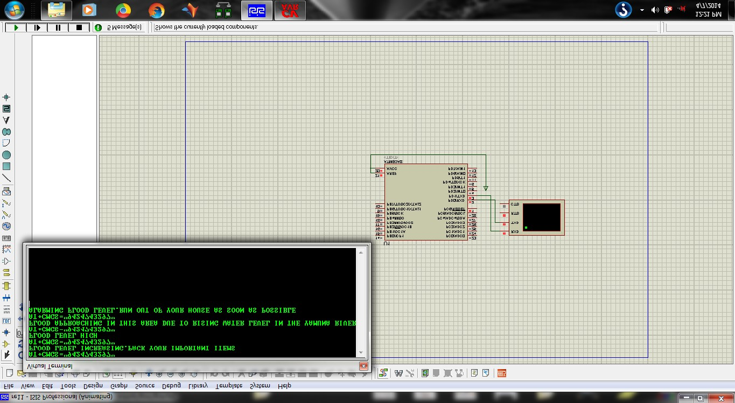

# Receiver simulation

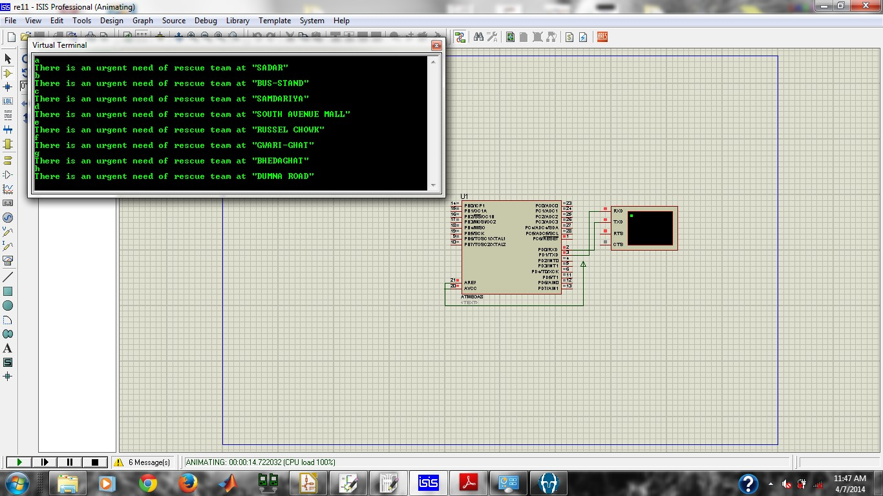

# RESULTS AND CONCLUSIONS

This product is designed such that it can cater the general public which is not aware of the scenario and need assistance in the time of flood. It does not require any bulky technical knowledge prior to use. Area code knob and frequency generation for signal transmission is done via the help of transmitter. This step generates a wave which has encrypted data for area identification. Receiver receives the data and decrypts the information for area prediction.

Processing of this information by disaster management organization. Measures taken to ensure the prevention of further harm to the informed area.

This system will help the management team to identify the victims and affected area. The principal problem of large loss of life and resources caused by the floods is caused due to lack of information.